**searching algorithm**

What is a search algorithm?

Whenever a search algorithm is implemented, it is a process that systematically locates a particular piece of data in a vast collection of data.

When might we need to use one?

The process of searching a large set of data would take an exceptionally long time, so using a search algorithm is the better solution.

**linear and Binary**

**Linear**

Counter = 0

**Target = 5**

Index 0 1 2 3 4 5

Values 2 4 5 6 9 10

In linear search, we start at index one. If we find our target, we stop. If not, we go to index 2 and add 1 to our counter. In this scenario, our target is 5. So, we start at index 0. the value is 2 so it is not our target, so we add 1 to counter and move across to index 1. index 1 =4 so we carry on, add 1 to counter and move on to next index. Index 2 = 5 which is not our target, so we carry on again and add 1 to counter. Index 3 is 6 which is our target, so we stop and output our counter. **Our counter is 3.**

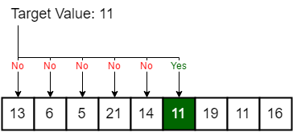**Counter = 5**

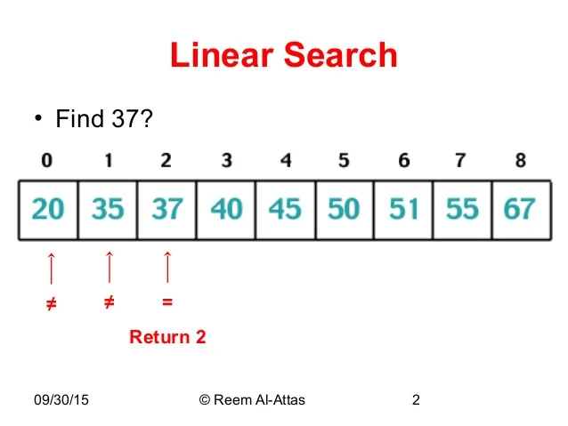**Counter = 2**

**Binary search**

